1. 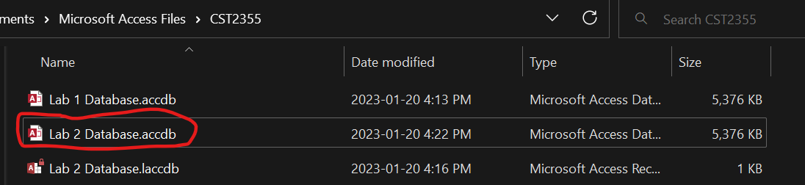
2. Text

   Description automatically generated
3. Graphical user interface, application

   Description automatically generatedTable

   Description automatically generatedGraphical user interface, text, application

   Description automatically generated  
   Note: DEPR stands for Department, Employees, (Employee) Privileges, Roles. Graphical user interface

   Description automatically generatedGraphical user interface, application, table

   Description automatically generated  
   Note: I don’t know why there’s only one record  
   Graphical user interface

   Description automatically generated  
   Note: Redone to sort relationships nicely  
     
     
   Table

   Description automatically generated with low confidence  
   A picture containing background pattern

   Description automatically generated  
   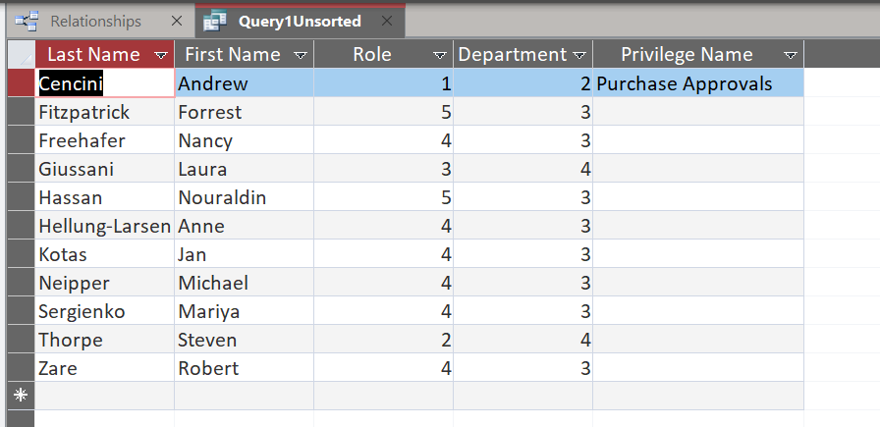  
   Table

   Description automatically generated
4. Graphical user interface, table

   Description automatically generatedGraphical user interface, application

   Description automatically generated
5. Table

   Description automatically generated  
   Table

   Description automatically generated  
     
   Note: renamed to EmployeeHobbyData  
   Table

   Description automatically generated
6. Table

   Description automatically generated
7. Table

   Description automatically generated  
   Table

   Description automatically generated
8. Graphical user interface, text, application

   Description automatically generated  
   Table

   Description automatically generatedTable

   Description automatically generated
9. Table

   Description automatically generatedGraphical user interface, application, table, Excel

   Description automatically generated  
   Note: This was after the MakeHobbies1 Make-Table query ran  
     
   Table

   Description automatically generated  
   Note: After step 9.4
10. Graphical user interface

    Description automatically generated  
    Table

    Description automatically generated
11. Graphical user interface, table

    Description automatically generated
12. Graphical user interface, text

    Description automatically generated
13. Table

    Description automatically generated  
    Note: Changed row 6 “Writing” to “Reading” on the excel sheet